Fire Fly Client Portal
This document explains the Fire Fly Client Portal in depth: what it is for, who uses it, how each area works, where data lives, and how it connects to Ignition, Microsoft Outlook, and SharePoint. It is written for operations and product understanding, not as a developer API manual.
Live site: https://clientportal.fireflyaccountancy.com
- Client Profile:
  - Add:
Basics: Who the client is and how the business is classified.
Field Name | Field Description
Unique ID | This is auto generated read-only field. Format: {Country}-{YYYYMMDD}-{NNN} More explanation available below.  Examples: US-20261026-001, CA-20261008-013, NS-20261015-022  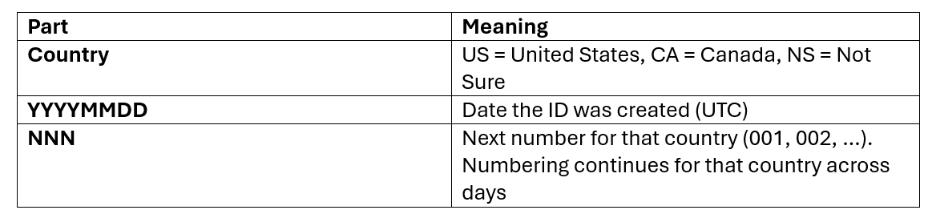
Legal Name | It is required, unique, text field.
Operating Name | It is the text field.
Industry | It is a Drop-down value. Lookup -> Dropdown -> Industry. Users can select or create new.
Business Activity | It is a Drop-down value. Lookup -> Dropdown -> Business Activity. Users can select or create new.
Entity Type | It is a Drop-down value. Lookup -> Dropdown -> Entity Type. Users can select or create new.
Website | Website Link
Year End | This will discussed with team

